REGISTRATION FORM
National Seminar on
ECONOMIC SLOWDOWN
IN INDIA: CAUSES AND CONSEQUENCES
27th February, 2020

Name :_________________
Institution :_________________
Designation : Student /Scholar/Faculty
Address :_________________
_________________
_________________
Pin Code :_________________
Mobile No : ________________
E-Mail : ________________
DD No :_________________
(Photo Copy of this Format can be used)
Place:
Date:
Signature of the Participant

ORGANISING TEAM

Patron : Dr. Sr. Gerardin Jayam
Secretary
President : Dr. Sr. Sophy,
Principal
Chairperson: Dr. S. Jeni Sanjana,
Head of the Department
Convener : Ms.S.Panimaya Mercy,
Assistant Professor
Co-Convener : Dr. A. Babila Kingsly,
Assistant Professor

Organizing Committee
Dr. J.M. Vinitha Charles
Dr. A. Sameema
Dr. S. Vimal Dolli
Ms. J. Josephine Shiny
Ms. M. Sahaya Vennila
Registration Fee
Students : Rs. 200/-
Research Scholars & Faculty: Rs. 250/-
Papers Presenters : Rs. 300/-
Publication fee : Rs.500/-
Kindly send the D.D infavour of Co-ordinator, Department of Economics, Holy Cross College, Nagercoil
For Further Details
Ms.S.Panimaya Mercy
 - 98416 08081
Dr.A.Babila Kingsly
 - 9003993704

HOLY CROSS COLLEGE (AUTONOMOUS)

Nagercoil – 629 004

National Seminar on
ECONOMIC SLOWDOWN
IN INDIA: CAUSES AND CONSEQUENCES
27th February, 2020

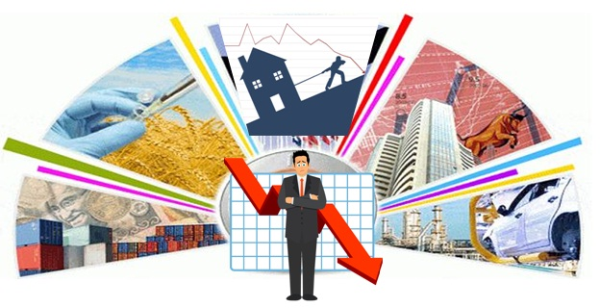

Organised by
Department of Economics
Holy Cross College (Autonomous)
Nagercoil – 629 004

About the College
Holy Cross College, Nagercoil is a Catholic College established and administered by the Congregation of the Sisters of the Cross of Chavanod. Holy Cross College, the first Women’s College in Kanyakumari District was inaugurated on 2nd August 1965. The college stands for total liberation and development of the whole person of the students in order to prepare them to take their rightful place and responsibility in the society. It offers 12 U.G., 10 P.G., 4 M.Phil. 8 Ph.D, programmes. It also offers many skills based, career oriented certificate and diploma courses.
About the Department
The Department of Economics is as old as the college itself. Having emerged as an undergraduate Department in 1967, developed as a PG department in 2003, it has now attained the status of a Research Centre. The department has produced many university rank holders in the past decades. The inter disciplinary PG course Business Economics (Self financed) was started in 2003. From 2016 it has been changed to MA Economics. The department provides opportunities to tap the talents and skills of our students. It promotes entrepreneurial awareness and nurtures social responsibility. It has collaboration with SRAEF, NGO’s and other centers.
About the Seminar
India has a vision of $5-trillion economy by 2024-25. To become a $5 trillion economy, India's GDP needs to go faster than what we grew at an average of 7.5 per cent in the last five years. In April, 2019,
IMF had predicted that India will grow at a rate of 7.2 per cent in the financial year

2019-20, but recent data indicates a fall in GDP growth i.e 4.5 per cent in the July-September quarter of 2019-20. The Government spending which is the usual panacea for growth has jumped nearly 12 per cent and propped up a falling GDP, but could not compensate for the fall in private investment. The decline in bank credit also cannot completely explain the demand slowdown. The steep fall in manufacturing and construction, and stagnant private investment which led to the fall in GDP still need to be explained. With this analysis and understanding on the impact of economic slowdown this topic has been chosen for enlightenment and discussion.
Call for Papers
Focusing on the above mentioned aspect, we call for research papers from academicians, research scholars and students in any one of the following sub themes or related themes.
- Automobile industry
- Causes of slowdown
- Consequences of slowdown
- Industrial slowdown
- Challenges in banking sector
Guidelines for paper presentation
- The soft copies of original and unpublished papers should be submitted on or before 12/02/2020 to holycrosseconomics@gmail.com
- The paper should not exceed 5 pages including tables and diagrams
- Font style – Times New Roman, Font size – 12 and line space 1.5
- The selected papers will be published in ISBN book. The additional fee of Rs.500 should be paid for publication.

Programme
9.15 AM : Registration
9.30 AM : Inauguration
Prayer Song : Dept. Choir
Welcome Address : Dr. S. Jeni Sanjana
Head & Assistant Professor
Department of Economics
Release of News
letter & Felicitation: Dr. Sr. Gerardin Jayam
Secretary
Release of Magazine
& Felicitation : Dr. Sr. Sophy
Principal
Release of book : Rev.Fr.Paul Raj,
St. Joseph’s Institute of Management, Trichy
Key Note Address : Dr. D. Kumar, Associate Professor of Economics
Jamal Mohamed College
Trichy
Vote of Thanks : Dr. J.M.Vinitha Charles
Technical Session
11.30 AM- 12.30 PM: Technical Session-I
Welcome Address : Ms. A. Sameema
Resource Person : Dr. Thaarcis Albin
Head & Associate Professor
Department of Economics
St. Xavier’s College
Palayamkottai
Topic : “Industrial growth performance in India then and now”
Vote of Thanks : Dr.S.Vimal Dolli
12.30-1.30 PM : Lunch
1.30-2.30 PM : Paper Presentation
2.30-3.15 PM : Valedictory
Welcome Address : Ms. J.Josephine Shiny
Valedictory Address: Dr. O.Y.Shirly
Assistant Professor,
Christian College
Trivandrum
Distribution of Certificates
Vote of Thanks : Ms. S.Panimaya Mercy

National Anthem

